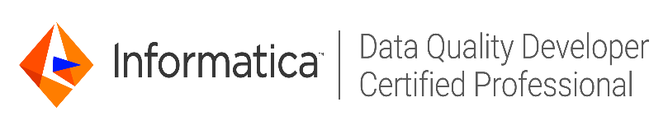
Shubham Mohan Bhardwaj
Informatica DQ/ETL Developer
Designation: Senior Software Engineer
Email: ninad.ramade@gmail.com
Phone: +91-8447628817
Company: HCL Technologies Limited
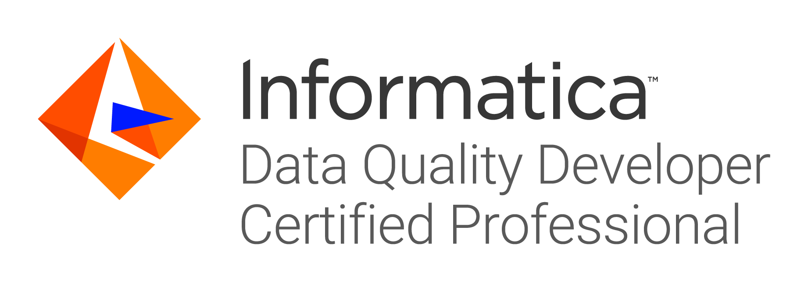

Career Objective

To make positive difference to the growth of the organization by delivering quality in every sphere of my presence and excel in whatever I am put in to. I would like to constantly upgrade my knowledge and skills, and prove myself as an asset to the organization.

Synopsis

- Certified Informatica Data quality developer specialist having 6+ years of work experience in Data analysis, Data quality and Data governance.
- Experience in Data enrichment, Data standardization, Address standardization and Validation, Data Deduplication, Matching, Consolidation and Data Governance.
- Experience in setting up data governance framework, policies, Data definitions and business glossaries.
- Experience in analyzing data, setting up Data quality KPI and Data validation rules for master data.
- Good command on ETL concepts, data modelling with a good experience of Life science and shipping industry domain CRM applications.
- Proficient in all the phases of Software development life cycle (SDLC) with Agile and Water Fall Methodologies and software testing life cycle.
- Worked extensively in analysis, design, implementation, testing and deployment phases for MDM and Data quality applications.
- Worked as Data Quality Analyst in Central Data Governance & Master data management team with Maersk Line Global Pune.
- Worked as Senior Data Quality Developer in Regulatory Reporting team with HCL for financial institution.
- Working as Senior Data Quality Developer and Analyst in a Data Governance Life Science project.

Professional Experience

Current Employer: HCL Technologies Limited, Pune
Duration: From Aug 2018 till date.
Role: Senior Software Engineer

Previous Employer 1: Maersk Global Service Centers, Pune
Duration: From Jun 2017 till Jul 2018.
Role: Central Data Steward and Data Quality Analyst

Previous Employer 2: Tata Consultancy Services
Duration: From Nov 2014 till Jun 2017.
Role: DQ & ETL Developer

Technical proficiency

Tool/Software type | Tool/Software Name
ETL/ Data Quality tool | Informatica Power center 8.6/9.X/10.X
ETL/ Data Quality tool | Informatica Data Quality 9.X/10.X
Data Governance tool | Informatica IDD 901/910, Collibra Data Governance
Test Management Tool | HP Quality Center 9.2/10
Database and SQL navigation tools | Oracle 9i /10g/11g
Database and SQL navigation tools | SQL Server Management Studio
Database and SQL navigation tools | Teradata
Operating System | Windows XP/7/8/10
Operating System | Linux
Reporting tool | SAP Business Objects 4.0
Ticket management/Task management tool | Service Now/JIRA
Office tools | MS Excel/ MS office (2007/2010/2016)

Award Details

Title | Received On
Champ of the month Award | 03/04/18
Extra Mile Award | 28/10/17
Star of the Month | 09/10/16
Star of the Learners group | 03/15/15

Others

- Extra-Curricular:

    - -Event manager in tech fest organized in college.

    - -Worked as team leader for project team during TCS training.

- Worked as Informatica Data Quality trainer in TCS.

Facilitated Talent Acquisition team to hire professionals in TCS

Academic Profile

Exam/Degree | Year of Passing | Board/University | Percentage Marks
B.Tech | 2014 | UPTU | 80.05
XII | 2010 | ISC | 74.32
X | 2008 | ICSE | 75.62

Projects Undertaken

Details of the assignments/projects that I have worked upon are listed in chronological order.

Company: HCL Technologies Ltd.
Project: Covance Apps
Technology: Informatica DQ 10.x, Informatica Power center 10.x, Collibra Data Governance, Microsoft SQL Server
Team size: 5 Members
Duration: Apr’2020 - till Date
Role: Senior Data Quality Developer

Project Summary:
- This project deals with implementation of Data governance framework enforcing consistent definitions throughout the organization, defining rules and business metric policies and ensuring no violation of data governance principles.
- DQ solutions includes data profiling and on that basis applying DQ checks through advanced transformations followed by integration with Power center for data load.
Responsibilities:
As a part of this project I have following responsibilities:

- Designing solutions and load strategies for ETL development to load data from multiple source systems on common landing area.
- Applying DQ checks on CTMS system by defining and developing the data quality rules and sending out the escalations wherever the discrepancies are found to the respective data owners.
- Setting up enterprise data on collibra data governance tool.
- Designing the dashboards, defining business metric policies.
- Facilitated as spoc for internal as well as external audits ensuring zero tolerance against any non-compliance.

Company: HCL Technologies Ltd.
Project: Regulatory Reporting VOLCKER -RECON
Technology: Informatica DQ 10.x, Informatica Power center 10.x, Control-M, Hive, Oracle SQL
Team size: 4 Members
Duration: Aug’2018 till Jan’2020
Role: Senior Data Quality Developer

Project Summary:
- This project deals with implementation of reconciliation framework for dealing with the data quality issues in regulatory reporting.
- Reconciliation process used to determine whether the money leaving an account matches the amount spent, ensuring the two values are balanced at the end of the recording period.
Responsibilities:
As a part of this project I have following responsibilities:

- Designing solutions and load strategies for ETL development to load data from multiple source systems on common landing area.
- Applying data cleansing and transforming the data in to regulatory reporting metrics.
- Applying DQ checks on metrics and sending out alerts to source systems to validate the data breaching regulatory guidelines.
- Setting up data quality validation rules and platform for regulatory reporting.
- Internal Quality Assurance(IQA).
- Meeting aggressive timeliness and delivering defect free optimized solution.

Company: Maersk Global Service Centers
Project: Data Governance Organization
Technology: Informatica DQ 10.x, Informatica Power center 10.x, Informatica MDM 10.1, Oracle SQL plus
Team size: 10 Members
Duration: Jun’2017 till Jul’2018
Role: Data Quality Analyst

Project Summary:
- This project involved defining and implementing Master data governance policies, data quality KPI and validation rules
- This project is scattered for multiple master data objects Customer, Facility, vendors, geographies which are implemented on Informatica MDM Hub.
Responsibilities:
As a part of this project I had following responsibilities:
- Analyzing data quality of all master data objects for global Maersk business.
- Setting up data quality validation rules and platform for data quality reporting.
- Setting up data governance policies for customer and geography master data objects.
- setting up data governance framework, Data quality KPI, Data definitions and business glossaries for Master and reference data
- Profiling & analyzing the master data, and various solutions such as implementing match between multiple master data.
- Involved in data cleansing with activities such as standardization to ensure the quality data and created web services.

Company: Tata Consultancy Services
Project: Enterprise Data Management & DQ Implementations
Technology: Informatica Power center 9.x, Informatica IDQ 9.5.1, SSMS - SQL Server, PL/SQL, Oracle 11g
Team size: 1 Member
Duration: Jan’2016 to Jun’2017
Role: DQ Developer & Administrator

Project Summary:
- This project deals with implementing the data quality solutions as per the rules stated by the client. Integrating the rules with Power Center.
- DQ solutions includes data profiling and on that basis applying DQ checks through advanced transformations followed by integration with Power center for data load.
Responsibilities:
As a part of this project I had following responsibilities:
- Providing technology training to the team members.

- Developing strategies for the team members to achieve the goals and monitoring their participation. Profiling the client data.
- Applying DQ checks on the client data along with integration with Power Center.
- Designing solution and load strategies for ETL development.

- Internal Quality Assurance(IQA)

- Meeting aggressive timeliness and delivering defect free optimized solution

Company: Tata Consultancy Services
Project: CCAR-IRIS Expansion
Technology: Informatica Power center 9.x, SQL, Oracle 11g, Teradata 14, SAP Business Objects 4.0, HP ALM
Team size: 15 Members
Duration: Jan’2015 to Jan'2016
Role: ETL Developer

Project Summary:
- This project maintains the master data in different data marts. Enterprise Information Integration service provides the capabilities to: collect; store; combine; manipulate; synchronize; Search; transform data and/or the evolving landscape of content. This service is comprised of multiple data integration services that deliver POCs, production support.
Responsibilities:
As a part of this project I had following responsibilities:

- Interaction with SMEs (Subject Matter Expert) regarding the requirements and data verification.
- Designing solution and load strategies for ETL development.
- Provided best possible solution to users to map the solution as per their line of Business which suites day to day activities.
- Process Project Documentation.

